**Review Report on Indian Agriculture Trends and Seasonality**

**Introduction**

India's agricultural landscape is characterized by remarkable diversity, complex seasonal patterns, and significant regional variations. This report provides a comprehensive analysis of crop varieties, seasonal distributions, and agricultural trends across different states in India.

**Crop Diversity and Composition**

**Major Crops Landscape**

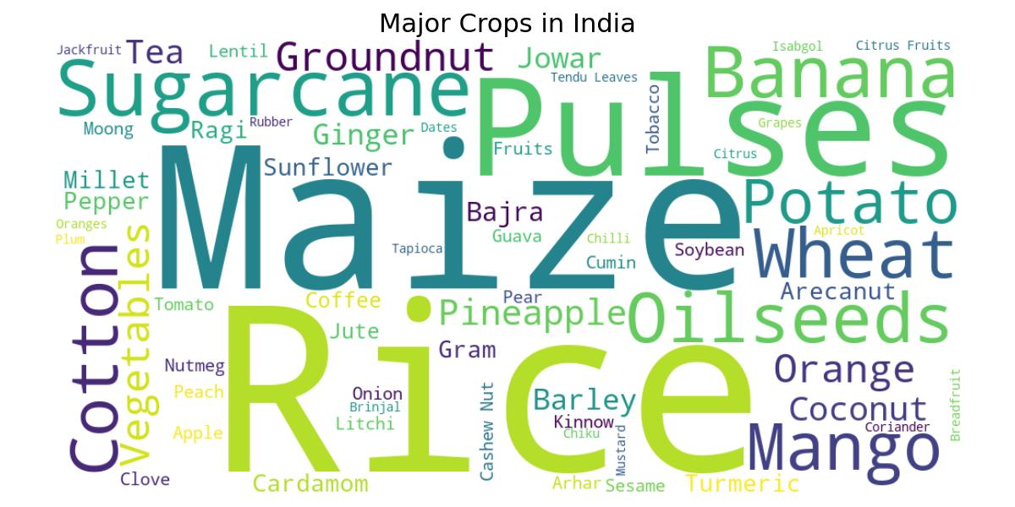

The agricultural panorama of India is incredibly diverse, encompassing a wide range of crops from staple grains like rice and wheat to cash crops like sugarcane and cotton. The word cloud visualization reveals the extensive variety of crops cultivated across the country, highlighting the agricultural complexity of the Indian subcontinent.

**Top 10 Crop Varieties by State**

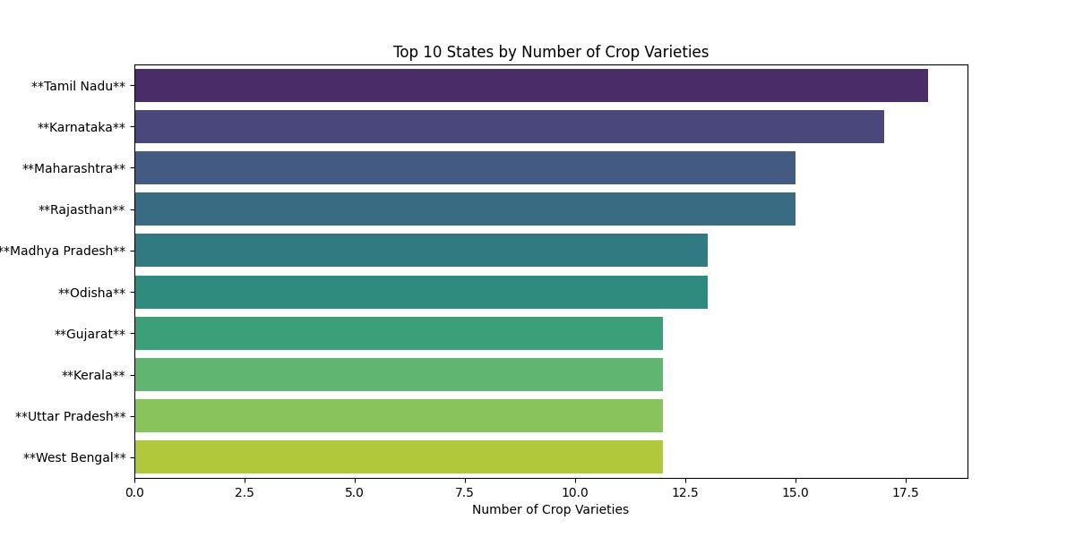

The state-wise analysis of crop varieties reveals interesting geographical patterns:

* Tamil Nadu leads with the highest number of crop varieties
* Karnataka and Maharashtra follow closely
* States like Kerala and Uttar Pradesh also demonstrate significant crop diversity

**Crop Distribution**

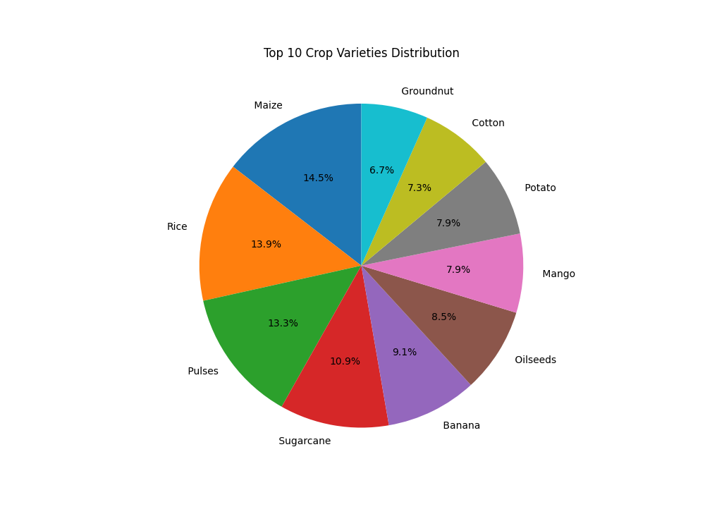

The pie chart of top 10 crop varieties shows a relatively balanced distribution:

* Maize: 14.5%
* Rice: 13.9%
* Pulses: 13.3%
* Sugarcane: 10.9%
* Other significant crops include groundnut, cotton, potato, mango, oilseeds, and banana

**Seasonal Crop Patterns**

**Kharif vs Rabi Crop Distribution**

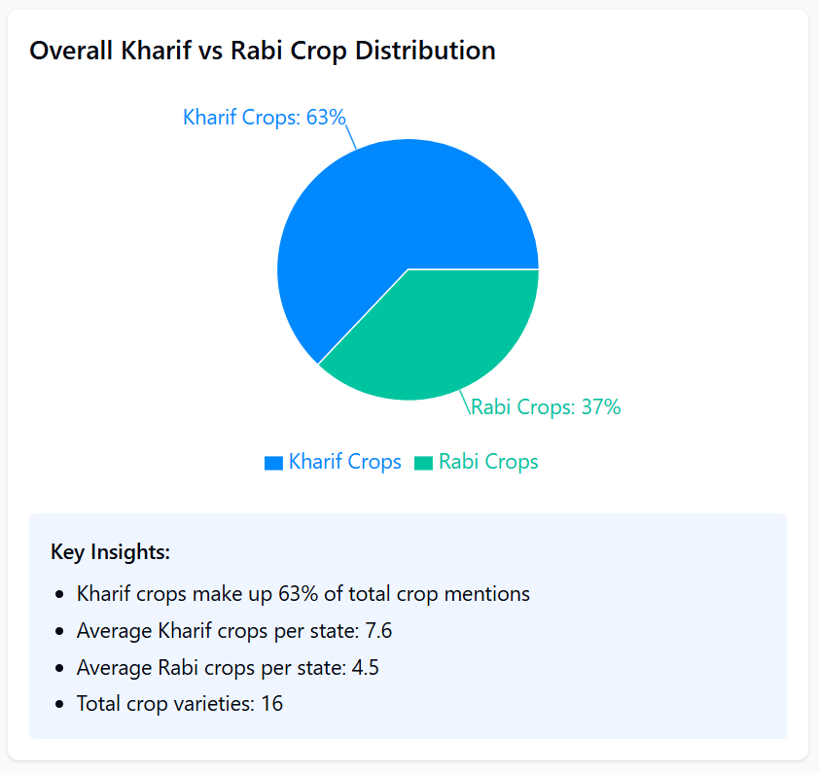

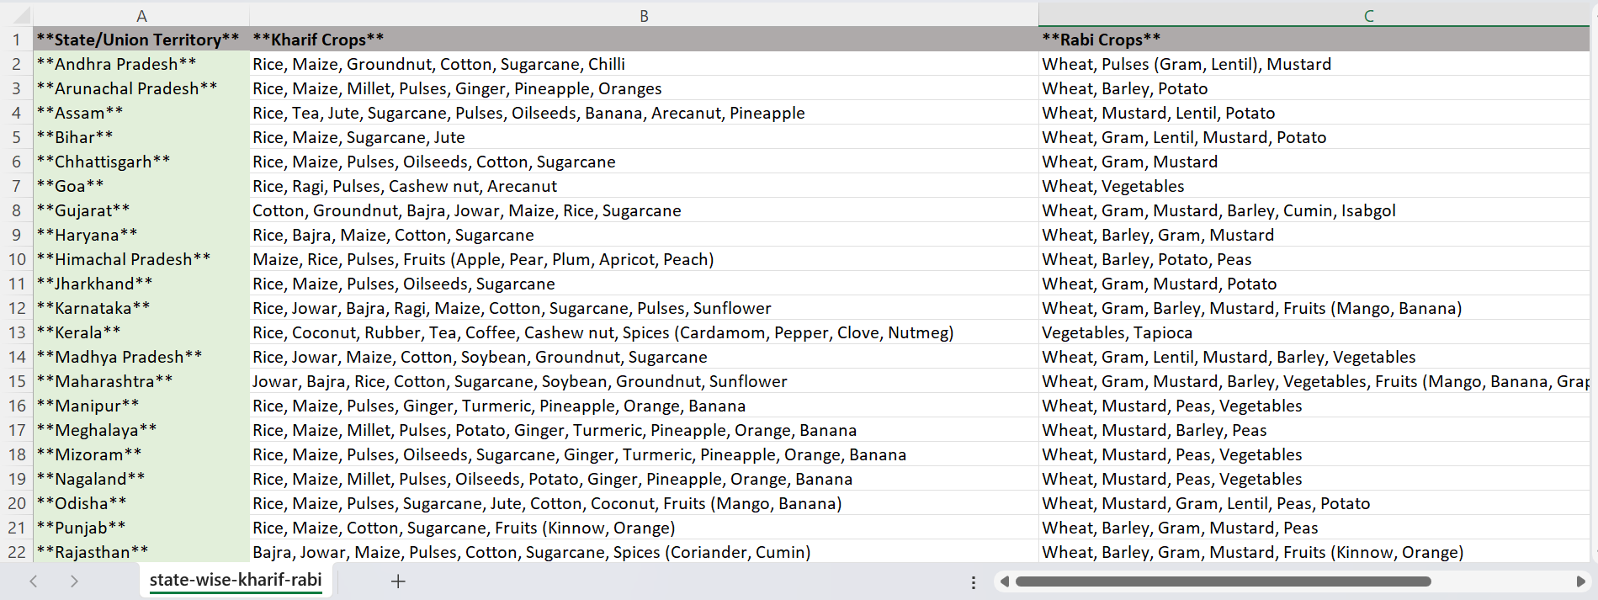

The seasonal crop distribution reveals:

* Kharif Crops: 63% of total crop mentions
* Rabi Crops: 37% of total crop mentions
* Average Kharif crops per state: 7.6
* Average Rabi crops per state: 4.5
* Total crop varieties: 16

**State-Level Crop Diversity**

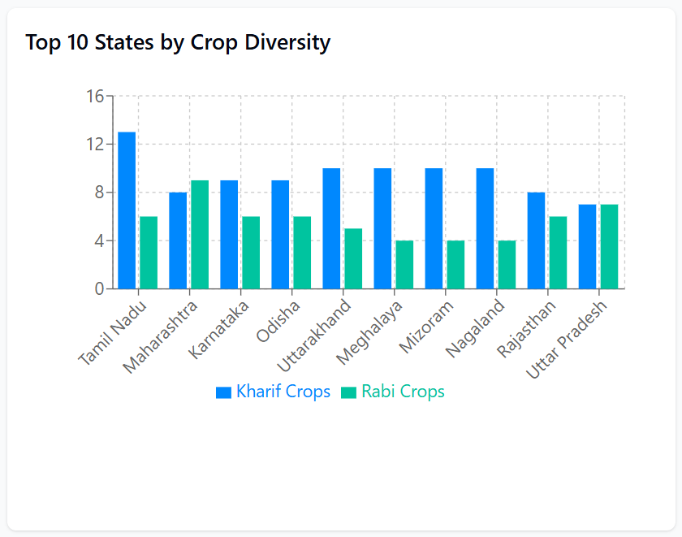

The crop diversity across states shows nuanced variations:

* Tamil Nadu demonstrates the highest diversity in both Kharif and Rabi crops
* Maharashtra and Karnataka show balanced crop portfolios
* Northern and southern states exhibit different cultivation strategies

**Detailed Seasonal Crop Insights**

**Kharif Crop Composition**

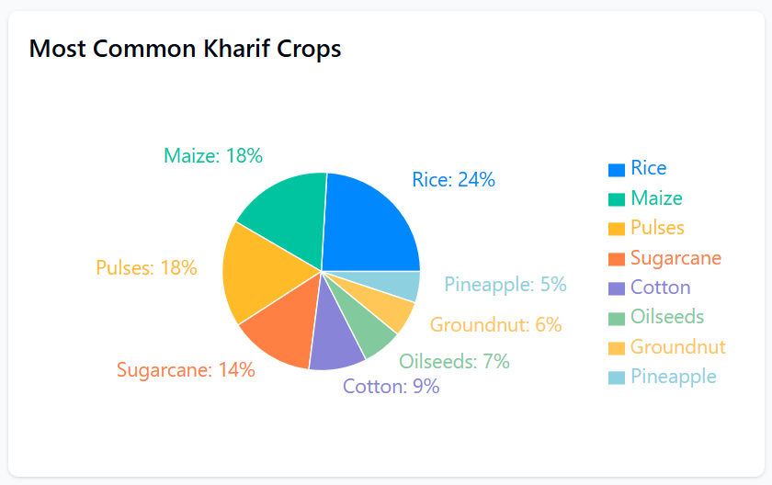

Kharif Crop Highlights:

* Rice dominates at 24%
* Maize and Pulses: 18% each
* Sugarcane: 14%
* Additional crops include cotton, groundnut, and pineapple
* Rice is the most widely grown Kharif crop, cultivated in 33 states
* Tamil Nadu leads in Kharif crop variety with 13 different crops
* Southern states tend to have more diverse Kharif crop portfolios

**Rabi Crop Composition**

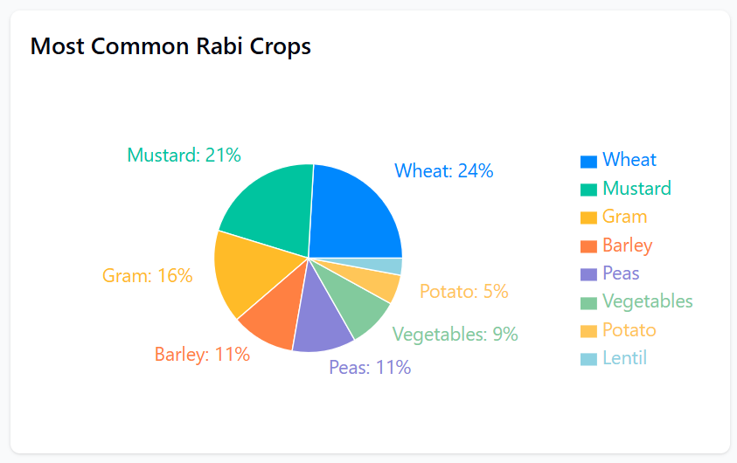Rabi Crop Highlights:

* Wheat leads at 24%
* Mustard: 21%
* Gram: 16%
* Barley: 11%
* Other crops include peas, vegetables, potato, and lentils
* Wheat is the most widely grown Rabi crop, cultivated in 33 states
* Maharashtra shows the most variety in Rabi crops with 9 different varieties
* Northern states generally demonstrate balanced Kharif and Rabi cultivation

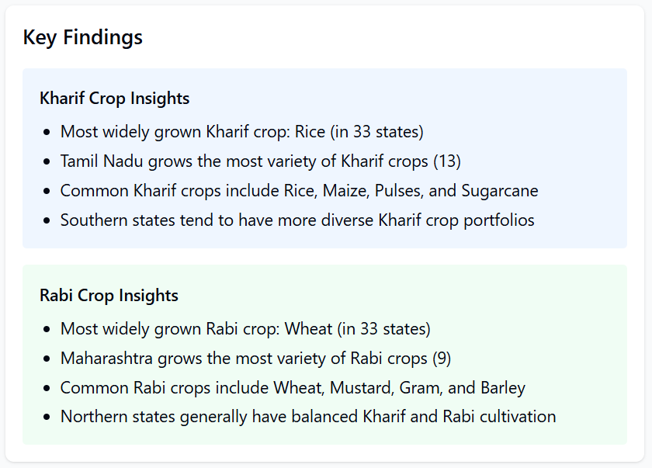

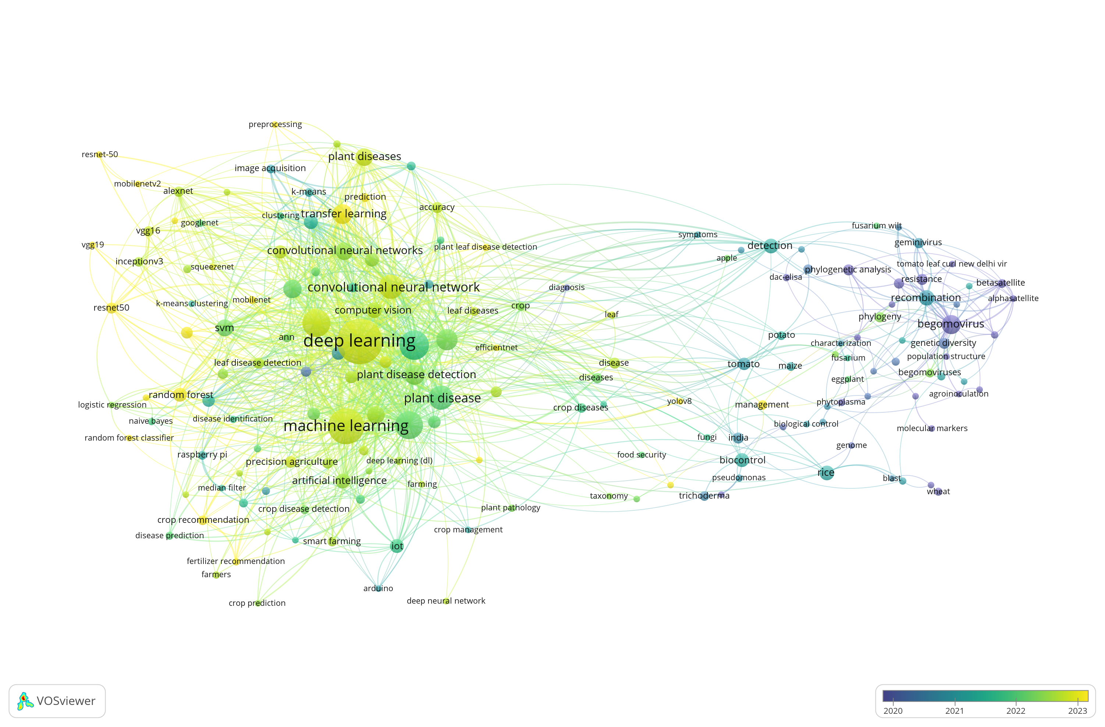

Network graph of literature survey – 1380 papers from Scopus

**Diseases**

**Kharif Crops:**

|  |  |  |
| --- | --- | --- |
| **Crops** | *Disease 1* | *Disease 2* |
| **Rice** | *Blast Disease* (Magnaporthe oryzae): Causes lesions on leaves, stems, and panicles, leading to significant yield loss. | *Bacterial Leaf Blight* (Xanthomonas oryzae pv. oryzae): Results in wilting and yellowing of rice plants. |
| **Maize** | *Turcicum Leaf Blight* (Exserohilum turcicum): Characterized by elongated grayish lesions on leaves. | *Common Rust* (Puccinia sorghi): Presents as reddish-brown pustules on leaf surfaces. |
| **Pulses** | *Ascochyta Blight* (Ascochyta spp.): Causes necrotic lesions on leaves, stems, and pods. | *Fusarium Wilt* (Fusarium oxysporum): Leads to yellowing and wilting of plants. |
| **Sugarcane** | *Grassy Shoot Disease* (Phytoplasma): Leads to excessive tillering and chlorotic leaves | *Red Rot* (Colletotrichum falcatum): Causes reddening and rotting of stalks |
| **Pineapple** | *Heart Rot (Phytophthora spp.): Results in rotting of the central stem and leaves.* | *Mealybug Wilt (associated with mealybug infestations): Causes reddening and wilting of leaves.* |
| **Groundnut (Peanut)** | *Late Leaf Spot (Phaeoisariopsis personata): Dark spots on leaves leading to defoliation.* | *Aflatoxin Contamination (Aspergillus flavus): Produces toxic compounds affecting seeds.* |
| **Oilseeds (e.g., Soybean, Sunflower)** | *Alternaria Blight (Alternaria spp.): Causes dark lesions on leaves and pods.* | *Downy Mildew (Plasmopara halstedii): Leads to yellowing and stunted growth.* |
| **Cotton** | *Boll Rot (various pathogens): Affects bolls leading to rotting.* | *Leaf Curl Virus (Begomovirus): Causes curling and thickening of leaves.* |

**Rabi Crops:**

|  |  |  |
| --- | --- | --- |
| **Crops** | ***Disease 1*** | ***Disease 2*** |
| **Mustard** | *White Rust* (Albugo candida): White pustules on leaves and stems. | *Downy Mildew* (Peronospora parasitica): Fungal growth on the underside of leaves. |
| **Wheat** | *Leaf Blight* (Alternaria triticina): Causes necrotic lesions on leaves. | *Spot Blotch* (Cochliobolus sativus): Dark brown lesions leading to premature drying |
| **Gram (Chickpea)** | *Ascochyta Blight* (Ascochyta rabiei): Necrotic spots on leaves, stems, and pods. | *Botrytis Gray Mold* (Botrytis cinerea): Gray mold on flowers and stems |
| **Potato** | *Late Blight* (Phytophthora infestans): Dark lesions on leaves and tubers. | *Early Blight* (Alternaria solani): Target-like spots on leaves. |
| **Barley** | *Powdery Mildew (Blumeria graminis f. sp. hordei): White powdery growth on leaves.* | *Leaf Rust (Puccinia hordei): Reddish-brown pustules on leaves.* |
| **Peas** | *Ascochyta Blight (Ascochyta pisi): Necrotic lesions on leaves, stems, and pods.* | *Powdery Mildew (Erysiphe pisi): White powdery growth on foliage.* |

**References:**

1. Agriculture Statistics at a Glance – 2022 Govt. of India Report by the Ministry of Agriculture